Graham Skeats

Project 3 Report

For Project 3 I initially wanted to work on identifying and annotating illegal gold mines in satellite imagery since I thought this would be an interesting and consequential application of computer vision. The problem I encountered was that there are relatively few gold mines in our data compared to agriculture or rivers. So I switched gears and started looking to identify images that contained evidence of agriculture. Since there is a larger set of data for this problem I think it will be easier to create useful training and test sets for my classifier once I have extracted the useful features. Additionally, I think that since the gold mining sites will have similar features to the agriculture site, such as unnatural lines and deforestation, I could apply the model I trained for agriculture and it might be able to identify gold mining sites as well.

For feature extraction I focused on histogram of oriented gradients (HOG) and local binary pattern as the algorithms to build my feature set to train my classifier. I think that local linear binary pattern will be useful since it can identify whether a region is flat, an edge, a corner, or non-uniform. To me the defining feature of agriculture are straight lines and corners where the forest has been cleared away to make a field for crops. Hopefully, LBP will identify these features strongly so that a classifier could later use them to predict whether an image contains these features that are indicative of agricultural activity. The HOG algorithm will similarly look for large changes (gradients) that are present along edges and other areas of abrupt changes in intensity. This will again exploit these straight lines, edges and corners, that otherwise wouldn’t really exist in nature without human intervention. Potential issues that I think this approach might have is that rivers might be able to create straight or nearly straight lines naturally, so there might be additional preprocessing or feature extraction needed in order to prevent false positives.

To build my data set I wrote a python function that chops up the satellite imagery into nxn images then saved certain chunks that contained evidence of agriculture and an equal number that did not. I did this for two different sized chunks, 750x750 and 1000x1000, since I am curious about how the size of the images will affect feature extraction and classification. For example, what if an image clearly contained a corner of a field filled with crops but the majority of the image is forest. This also raises the issue of annotation and should the important features be in the center of the image. I think that since in practice the agriculture may not be in the center of a large satellite image it is useful to train a classifier to work with images that aren’t focused on important features.

Agriculture Containing Images 750x750

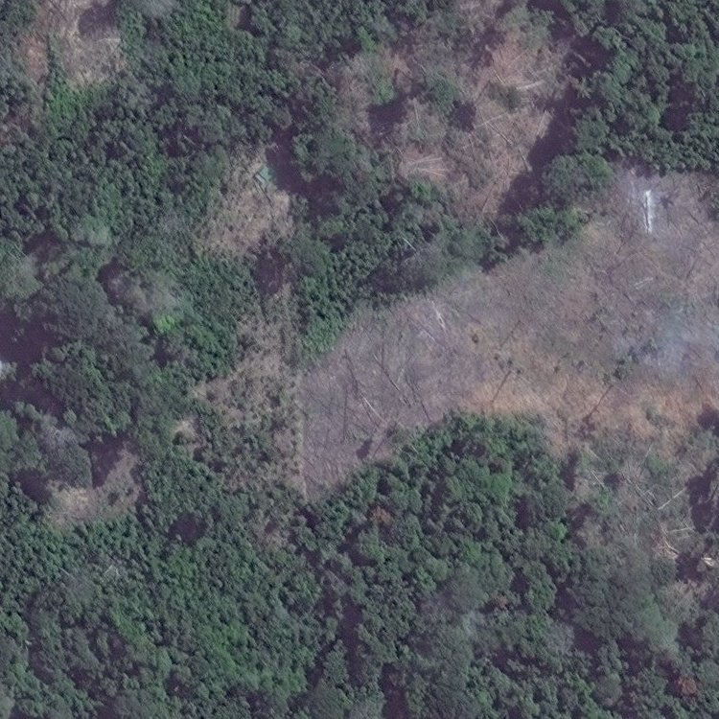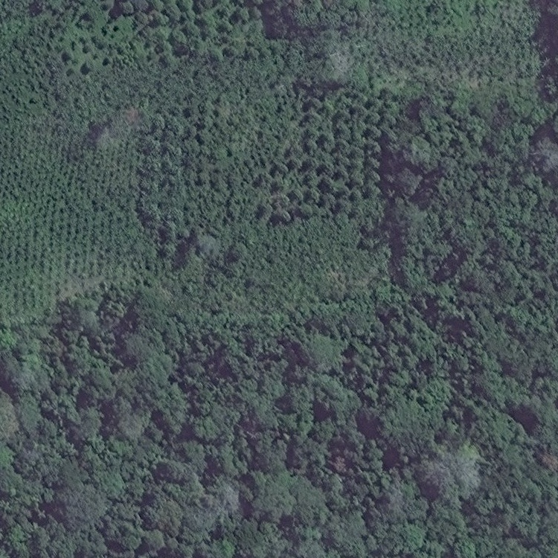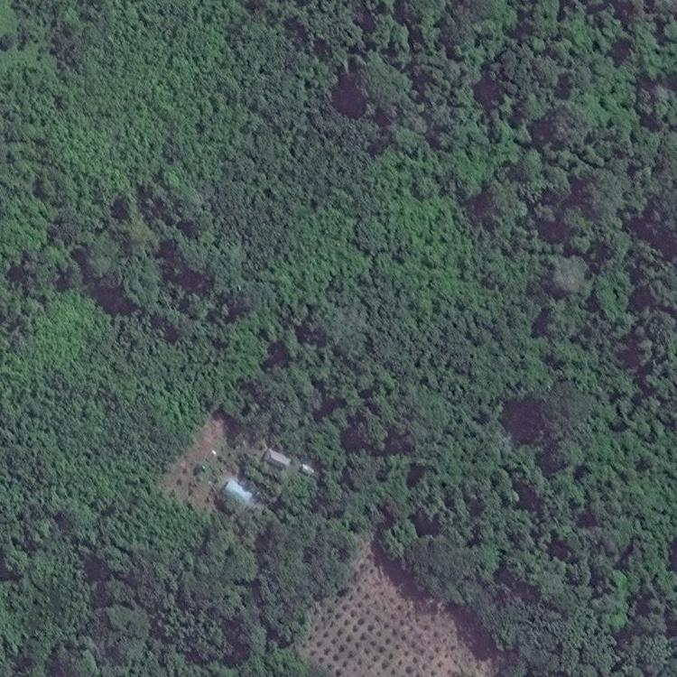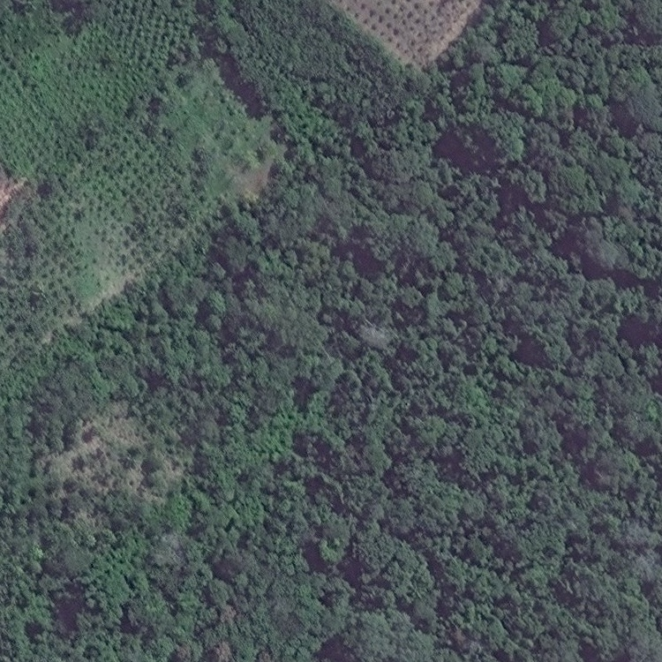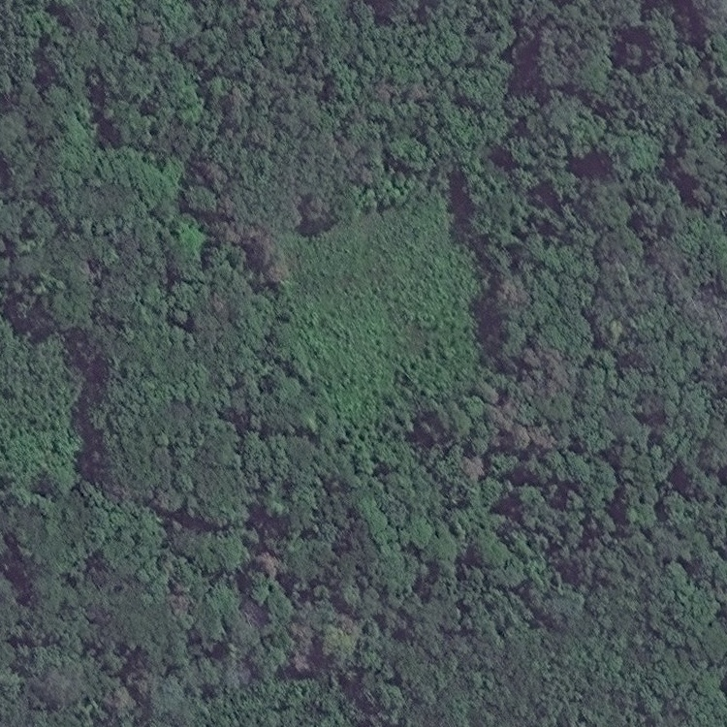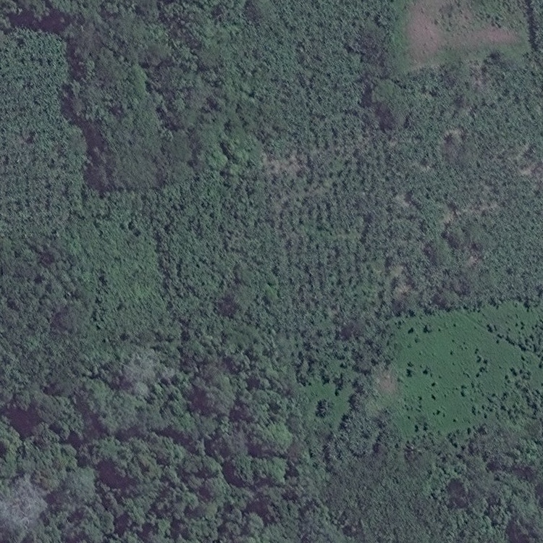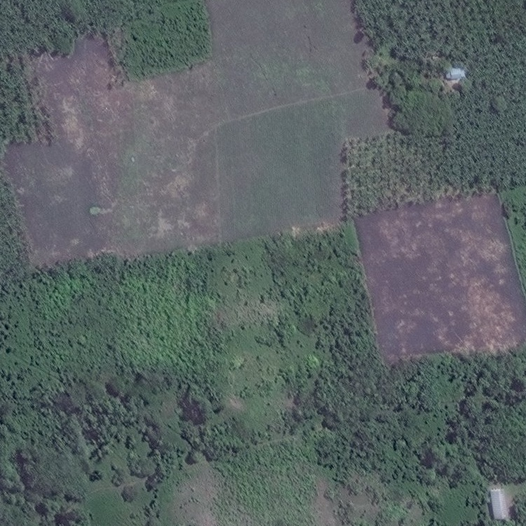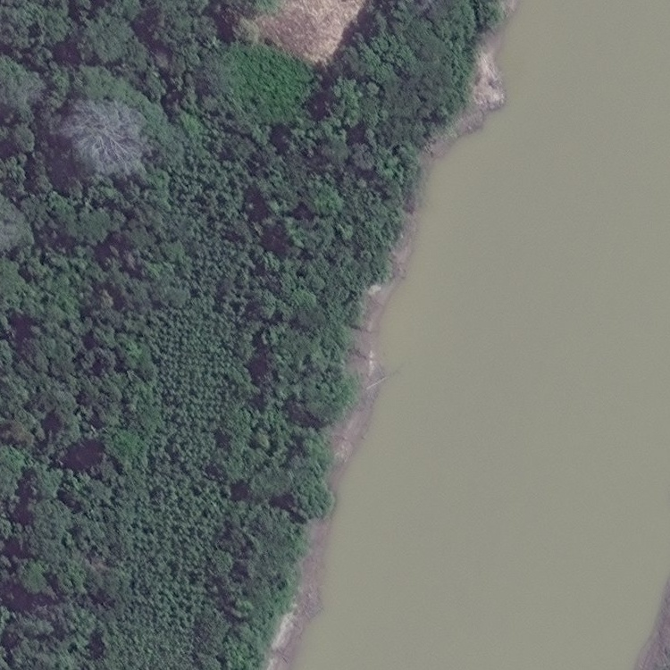

Images without evidence of Agriculture 750x750

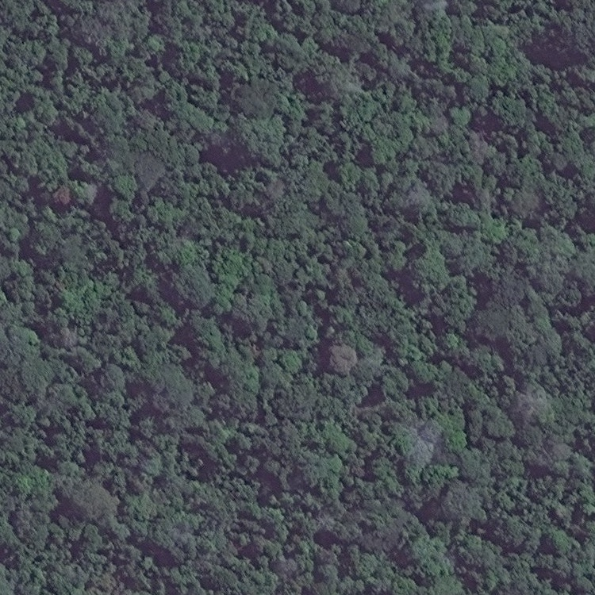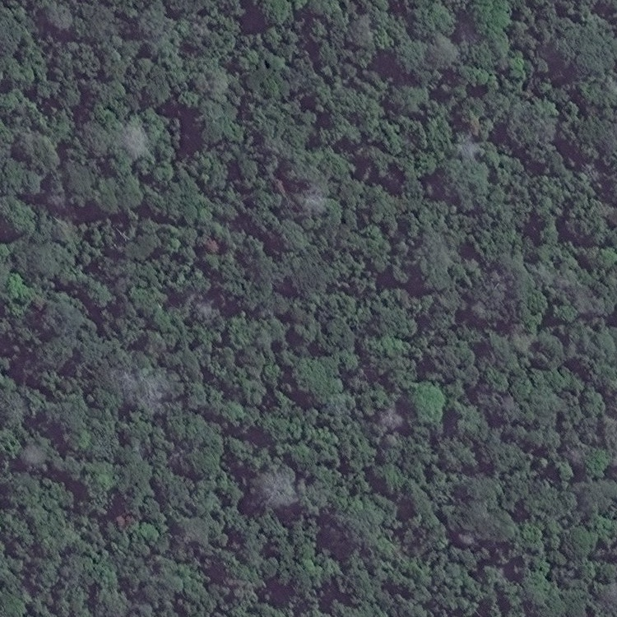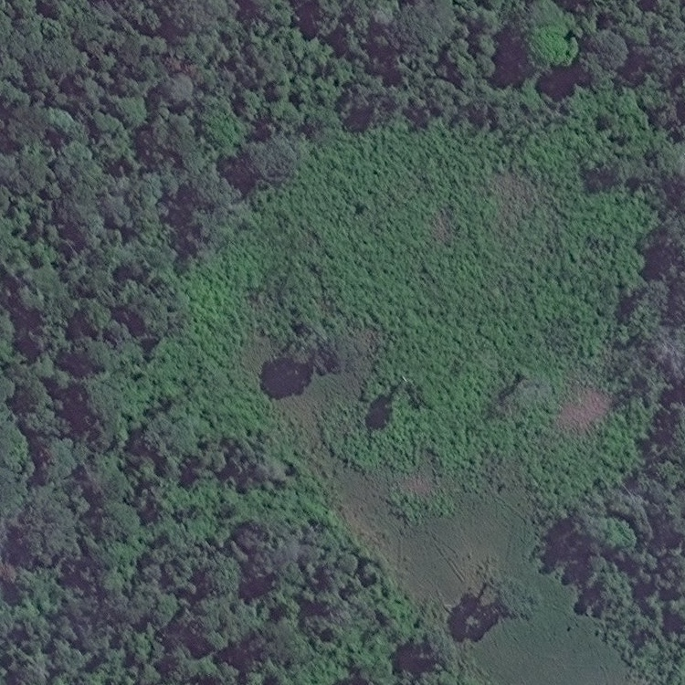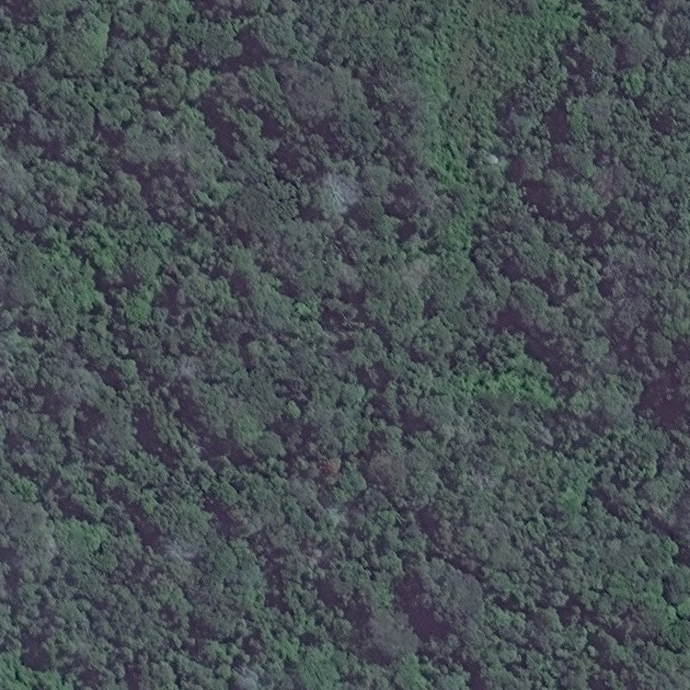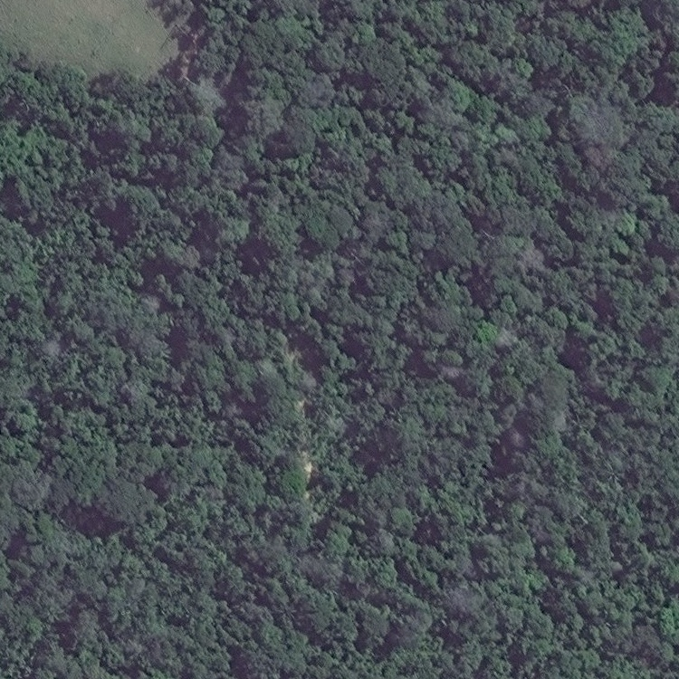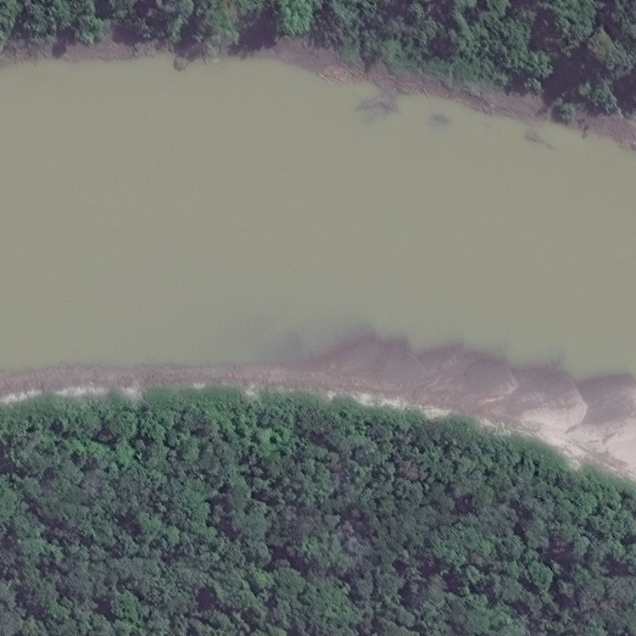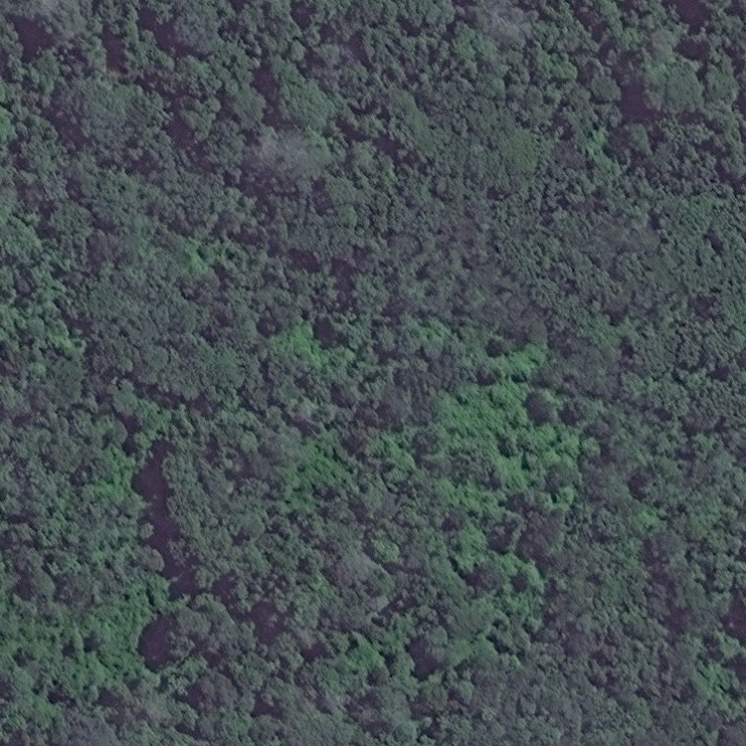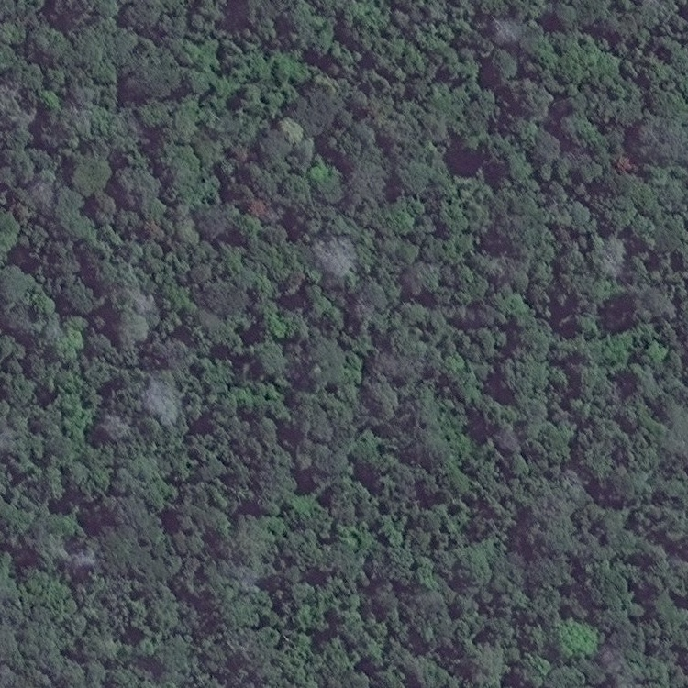

LBP Feature Extraction

The first feature extraction algorithm that I worked with was local binary pattern. LBP works by looking at the area around a pixel and measuring if they are less than or greater than that particular pixel. LBP measures a collection of LBPs over an image patch/area the distribution of these LBPs can be analyzed. The measurements around the pixel then give an idea of whether the pixel occurs at an edge, corner, flat surface, or a non-uniform area.

I started out by simply using the LBP script on some of my data images. The results were interesting but unfortunately the histograms didn’t reveal any obvious differences to the human eye.

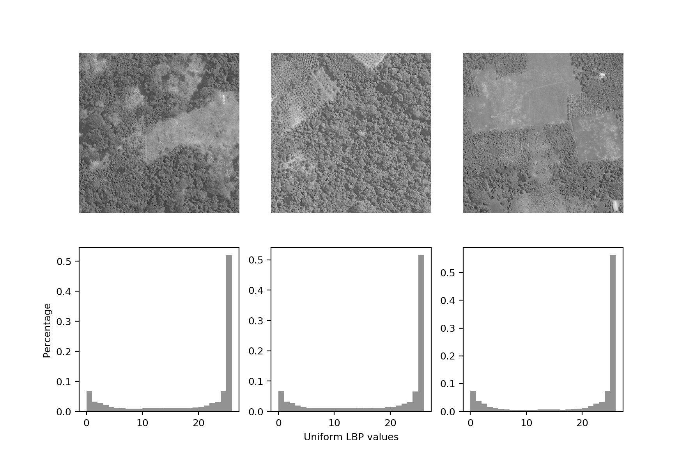

Figure 1 LBP histogram of agricultural images with default parameters.

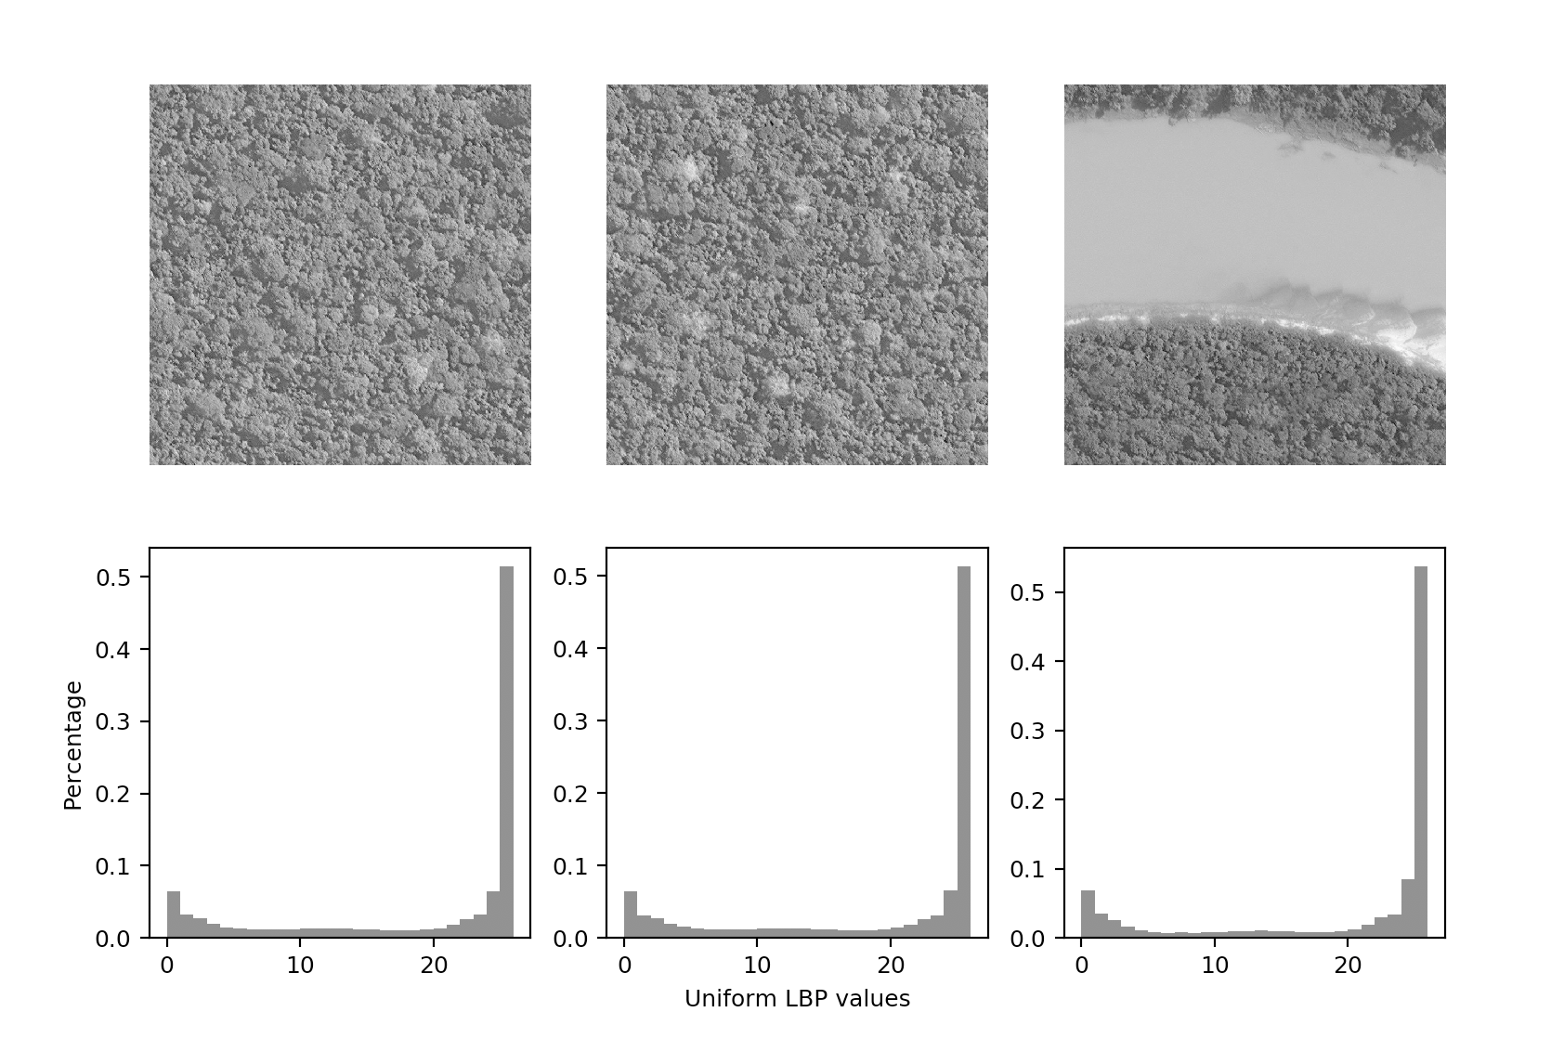

Figure 2 LBP histogram of non-agricultural images with default parameters.

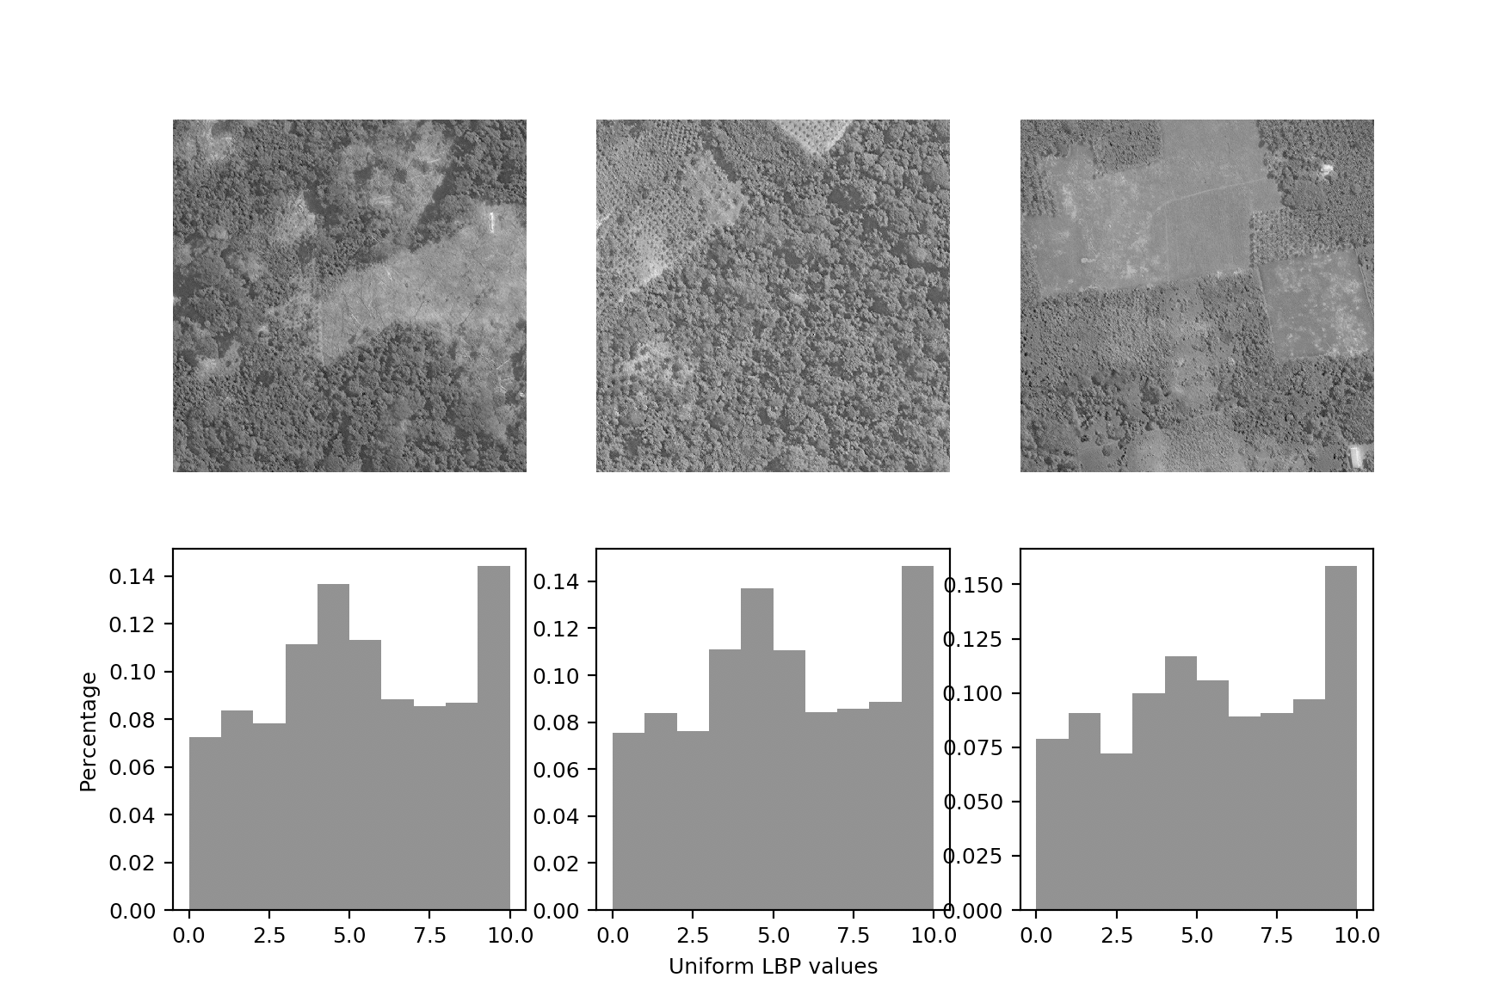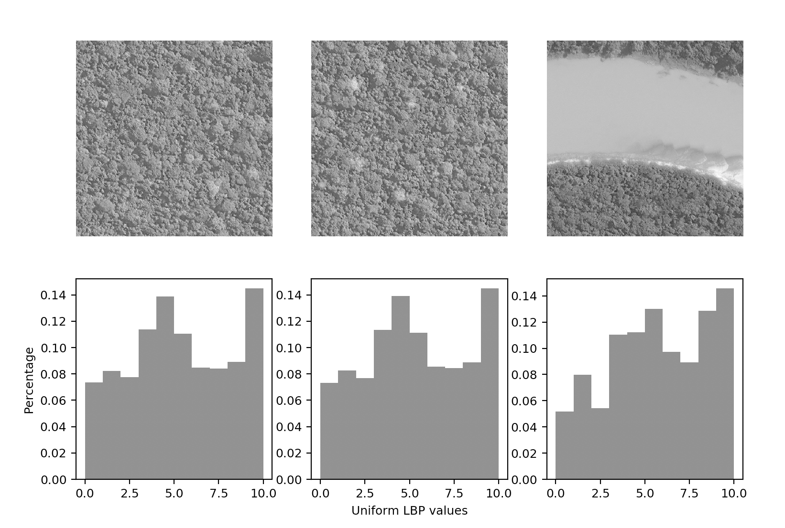 As you can see above, using the default parameters to the local_binary_pattern function successfully produced LBP histograms but without strongly identifying features to separate the data sets. There appears to be a slight difference in the center of the histogram around LBP values of 10-20 where the images of the only the forest are slightly higher. This difference might be enough for a machine learning classifier to separate the data but to try and find LBP results that better separate the sets I messed around with the parameters a little bit.

Figure 3 Agricultural images with LBP radius set to 1.

Figure 4 Non-agricultural images with LBP radius set to 1.

First by setting the radius of the LBP algorithm to 1, which looks at the intensity changes around a particular pixel more finely but decreases the number of samples that it ends up taking. This is why the histogram is now more evenly distributed along its values. This change made slightly more distinguishable results especially when you look at the third result for the agricultural images, but still not great. Si next I tried to increase the number of samples measured by increasing the factor that multiplies the n_points parameter. Unfortunately this gave me far worse results than the original parameters had so I tried reducing it which produced these results.

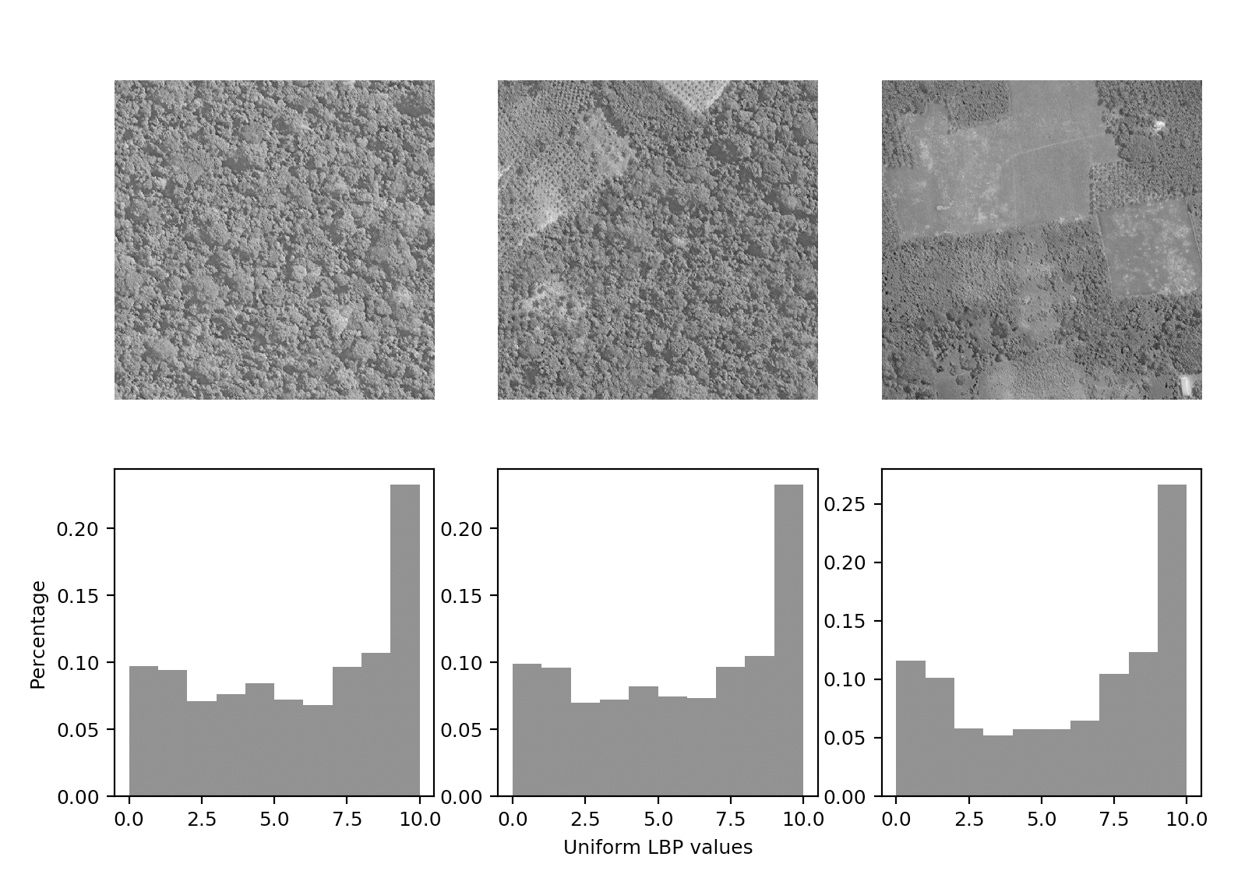

Figure 5 The first image is non agricultural while the second two are images of agricultural activity, n_points set to radius *4.

These histograms are again a little better since you can see that there is a more pronounced pattern in the histogram resulting from the third image. However, once again I am not sure if this is enough to be able to cleanly separate the data sets so LBP may not be the optimal feature extraction algorithm for this problem.

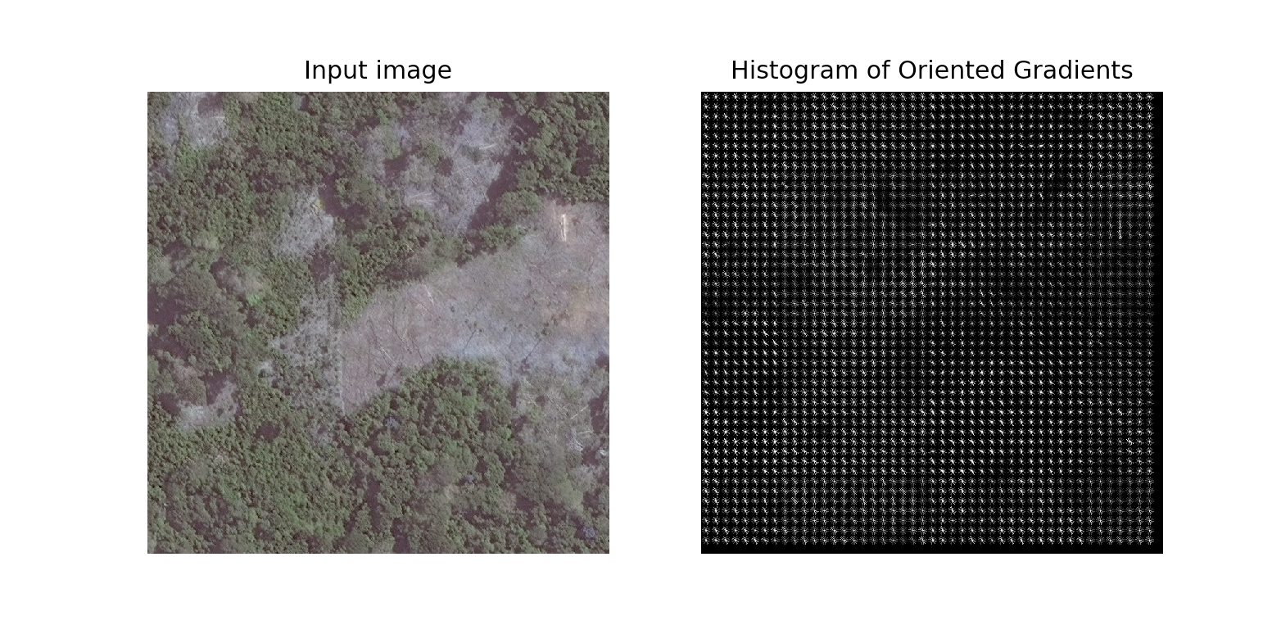HOG Feature Extraction

Figure 6 HOG for agricultural image with default parameters.

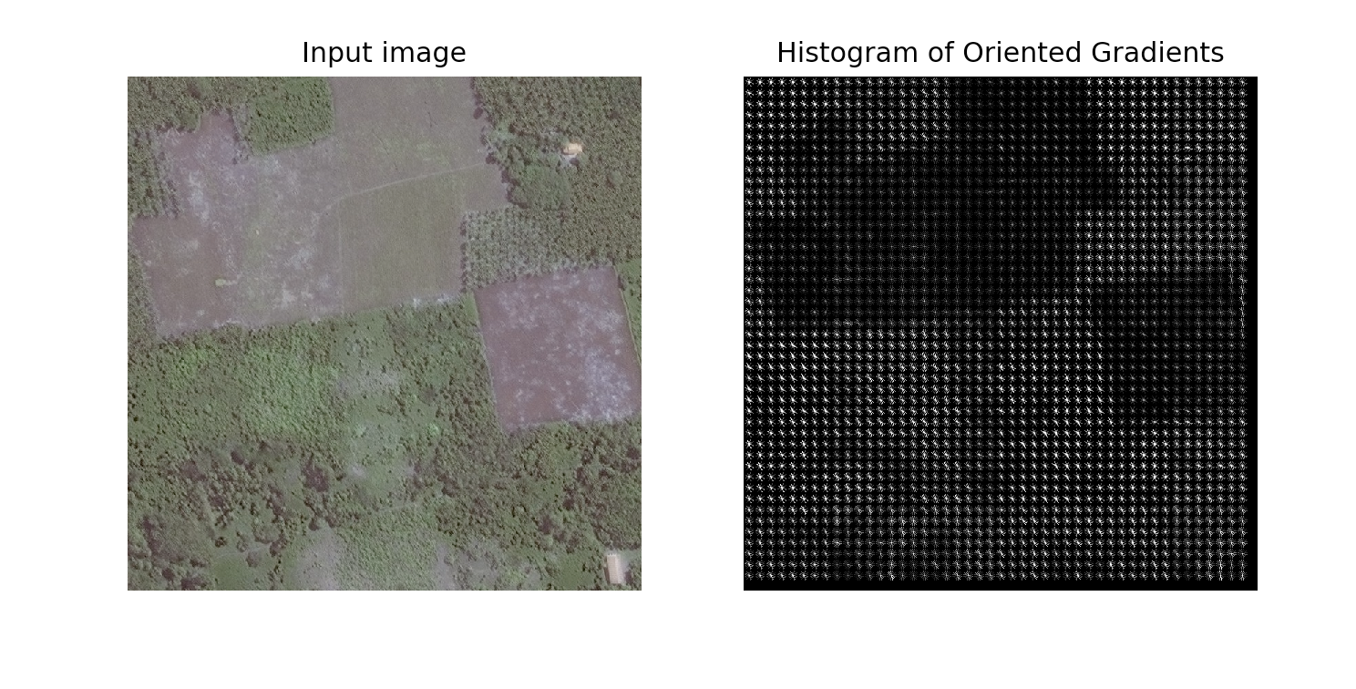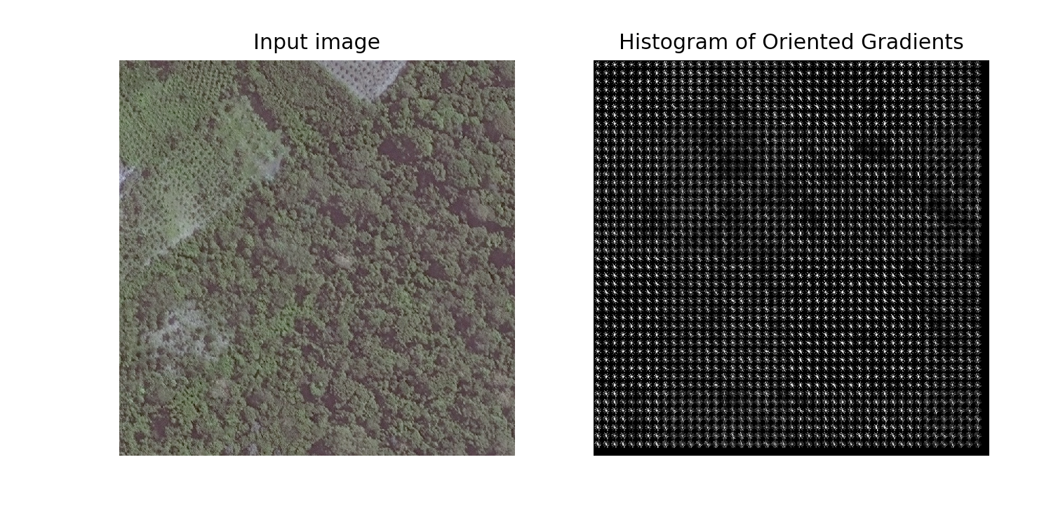 Histogram of oriented gradients (HOG) works by calculating the direction and magnitude for changing intensity for an area. These oriented gradients are then fed into a histogram or are overlaid on the original image to reflect where these gradients actually occurred. I found that the histograms were interesting but not as useful as the overlays which gave clear results that have promise for use with a classifier. As you can see in the results above the HOG clearly reflects the flat regions where the forest has been cleared away to make fields and there is little to no change in intensity in the pixels. Without change there are no large gradients so the fields and other areas that are cleared are reflected in these dark patches. This is not present in the nonagricultural imagery except for the river since the color of the river should be the same across its width which would be a “flat” area to the HOG.

Figure 7 HOG for agricultural image with default parameters.

Figure 8 HOG for agricultural image with default parameters.

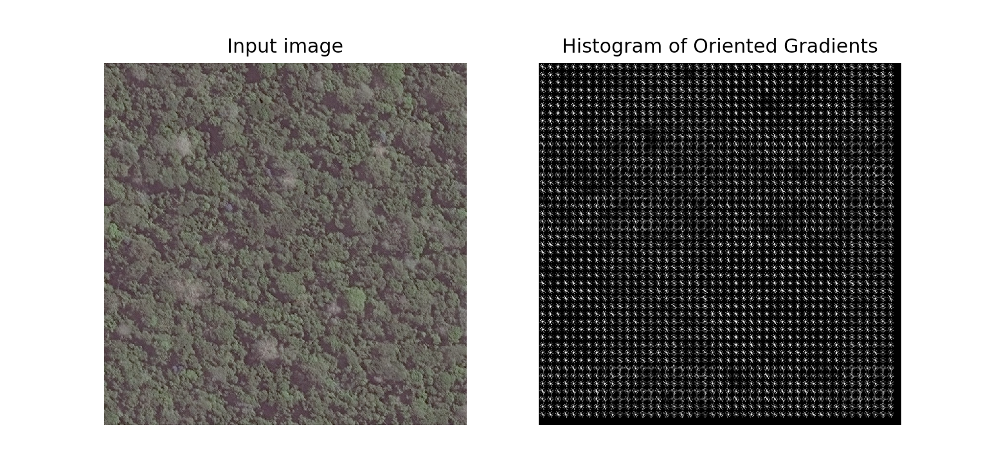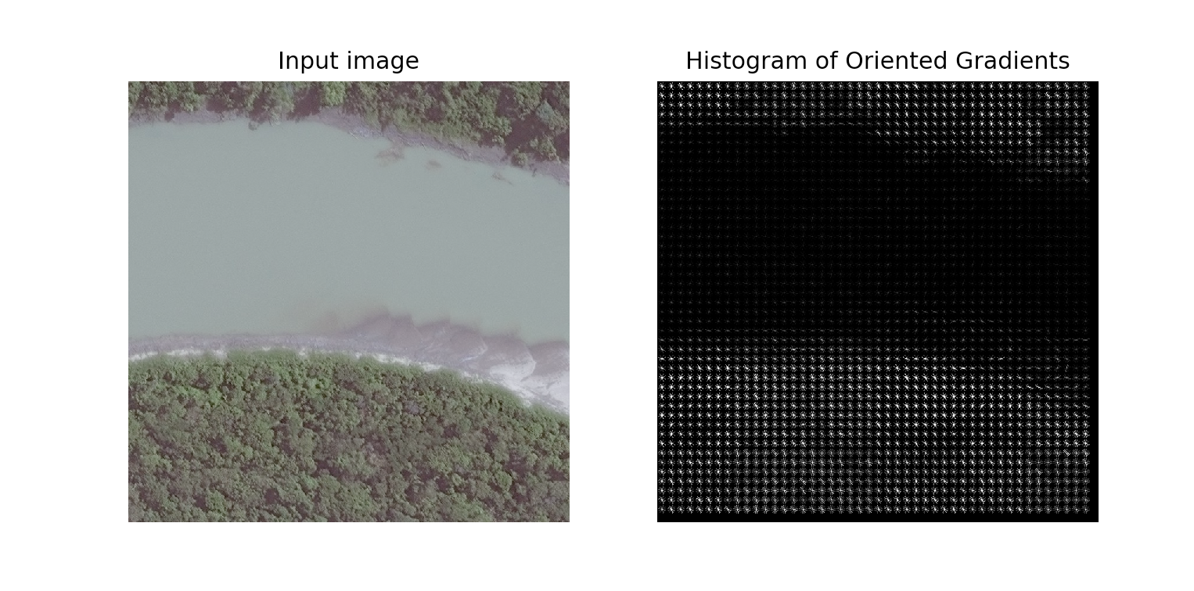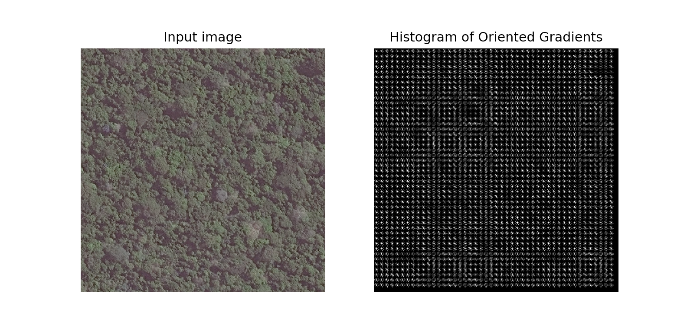 I also played around with changing some of the default parameters but didn’t find a change that clearly improved the results. If my classifier is struggling to separate the data then I will increase the pixels per cell since that appeared to increase the intensity of the gradients without affecting the flat regions.

Figure 9 Non-agricultural image with HOG, default parameters.

Figure 10 Non-agricultural image with HOG, default parameters.

Figure 11 Non-agricultural image with HOG, default parameters.

Gabor Filter Feature Extraction

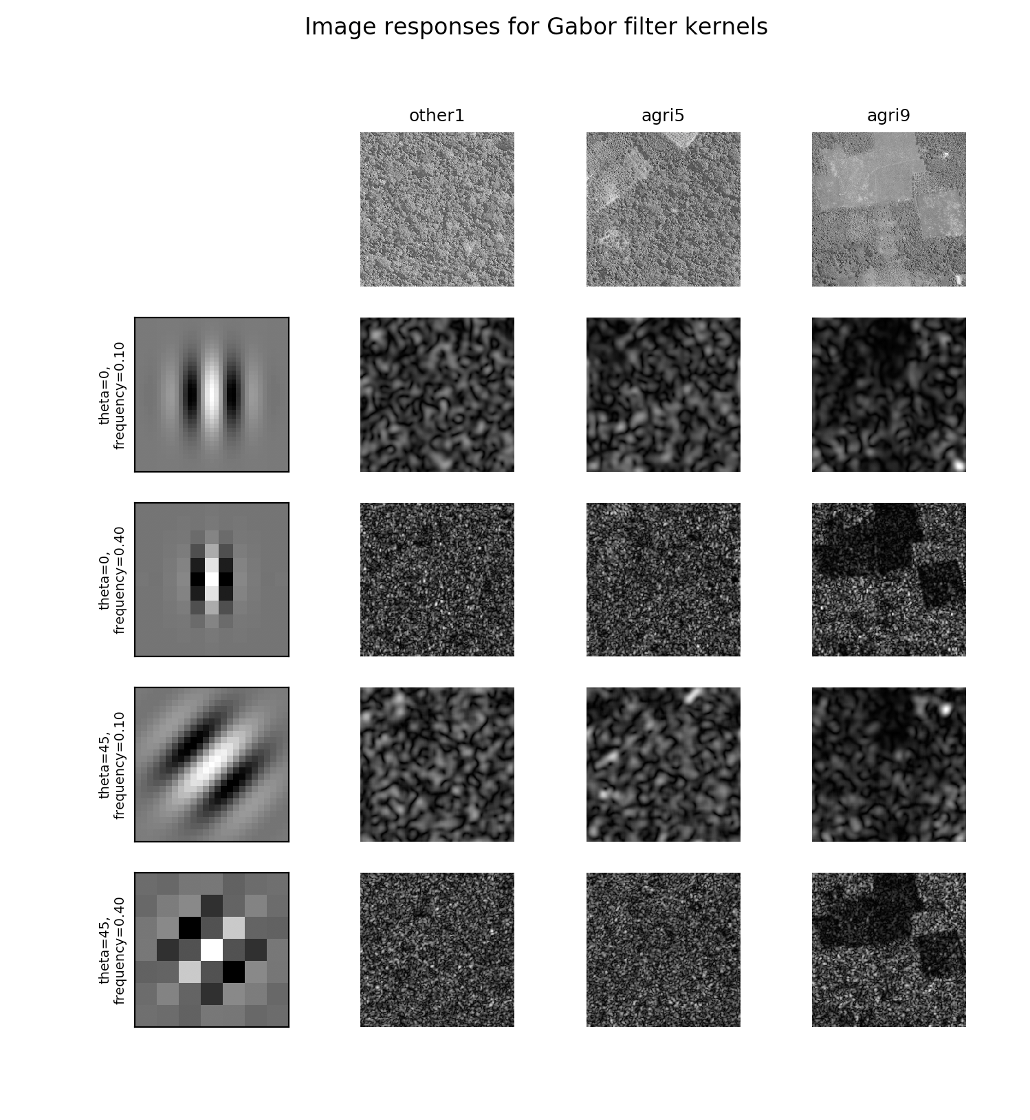 While the HOG feature set seems promising I also checked the Gabor textures algorithm to see if it offered any improvement. Gabor filters work by passing an image through a variety of Gabor filters which capture some frequency information from the image as a way to extract information from an image. However, this did not offer any improved results on the images. I believe this is due to the fact that there is very little frequency information in these fields or the forest and as a result wouldn’t be useful for this problem since we are focused on features like lines and edges.

Figure 12 Gabor response to one non-agricultural image (other1) and two agricultural images (agri5, agri9).